|  |  |
| --- | --- |
| Date | 08 November 2022 |
| Team ID | PNT2022TMID47367 |
| Project Name | Customer Care Registry |
| Maximum Marks | 4 Marks |

Data Flow Diagram & User Stories

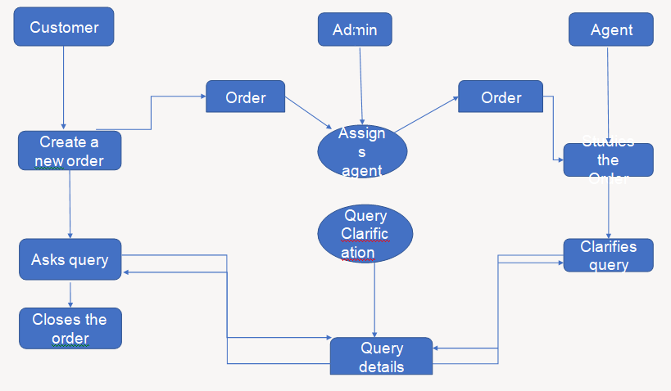

**User Stories**

Use the below template to list all the user stories for the product.

|  |  |  |  |  |  |  |
| --- | --- | --- | --- | --- | --- | --- |
| **User Type** | **Functional**  **Requirement (Epic)** | **User Story**  **Number** | **User Story / Task** | **Acceptance criteria** | **Priority** | **Release** |
| Customer  (Mobile user) | Registration | USN-1 | As a customer,I can register for the application by entering my email, password,  and confirming my  password. | I can access my account / dashboard | High | Sprint-1 |
|  | login | USN-2 | As a customer, I can login to the application  by entering correct email  and password. | I can access my  account/dashb oard. | High | Sprint-1 |
|  | Dashboard | USN-3 | As a customer, I can see all the orders  raised by me. | I get all the info needed in  my dashboard. | Low | Sprint-2 |
|  | Order creation | USN-4 | As a customer, I can place my order with  the detailed description of  my query | I can ask my query | Medium | Sprint-2 |
|  | Address Column | USN-5 | As a customer, I can have conversations  with the assigned agent and get my  queries clarified | My queries are clarified. | High | Sprint-3 |
|  | Forgot password | USN-6 | As a customer, I can reset my password by this  option incase I forgot my old password. | I get access to my account  again | Medium | Sprint-4 |
|  | Order details | USN-7 | As a Customer ,I can see the current stats of order. | I get a better understanding | Medium | Sprint-4 |
| Agent  (web user) | Login | USN-1 | As an agent I can login to the application by  Entering Correct email and password. | I can access my account /  dashbo ard. | High | Sprint-3 |
|  | Dashboard | USN-2 | As an agent, I can see the order details assigned to me by admin. | I can see the tickets to  which I could answer. | High | Sprint-3 |
|  | Address column | USN-3 | As an agent, I get to have conversations with  the customer and clear his/her do buts | I can clarify the issues. | High | Sprint-3 |
|  | Forgot password | USN-4 | As an agent I can reset my password by this | I get access to my account | Medium | Sprint-4 |

|  |  |  |  |  |  |  |
| --- | --- | --- | --- | --- | --- | --- |
|  |  |  | option in case I forgot my old password. |  |  |  |
| Admin (Mobile user) | Login | USN-1 | As a admin, I can login to the appliaction by enteringCorrect email  and password | I can access my account/dashb oard | High | Sprint-1 |
|  | Dashboard | USN-2 | As an admin I can see allthe orders raised in the entire system and  lot more | I can assign agentsby seeing those  order. | High | Sprint-1 |
|  | Agent creation | USN-3 | As an admin I can createan agent for clarifying the customers  queries | I can create agents. | High | Sprint-2 |
|  | Assignment agent | USN-4 | As an admin I can assignan agent for each order created by the customer. | Enable agent to  clarify the queries. | High | Sprint-1 |
|  | Forgot password | USN-5 | As an admin I can resetmy password by this option in case I forgot my old  password. | I get access to my account. | High | Sprint-1 |